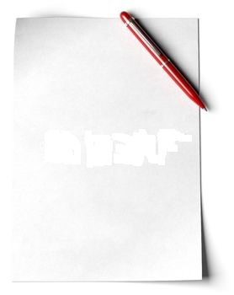
Dear Mum and Dad!

I'm having a great time
on the farm.
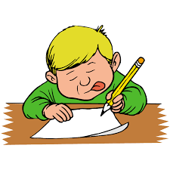
It's sunny today. I'm wearing my green shirt top and red shorts. I'm helping grandma with the ducks and chicken.
I love it here!
See you soon.

Kirill

